RenWeb Instructions
Here are step-by-step instructions with pictures of how to get onto RenWeb and find the Weekly Schedule of what we are doing each week.
Once you log into RenWeb, click on Student Information tab on the left-hand side, then you will need to click on your child’s name.
You should see the following screen. Click on any subject title along the right-hand side.
These are the instructions for Miss Unrue’s page, but it will be the same steps for my class!
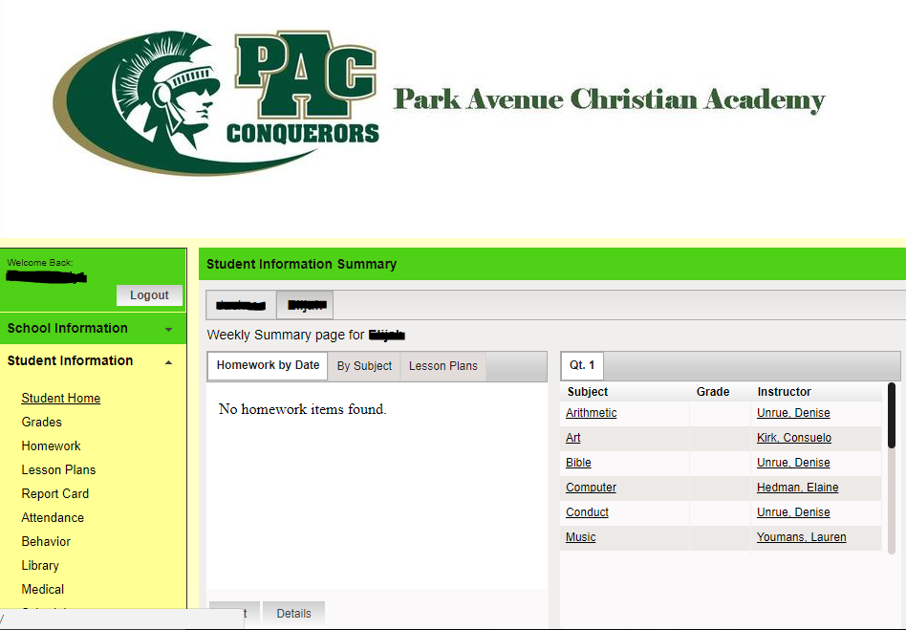

Then click on Resources along the top menu.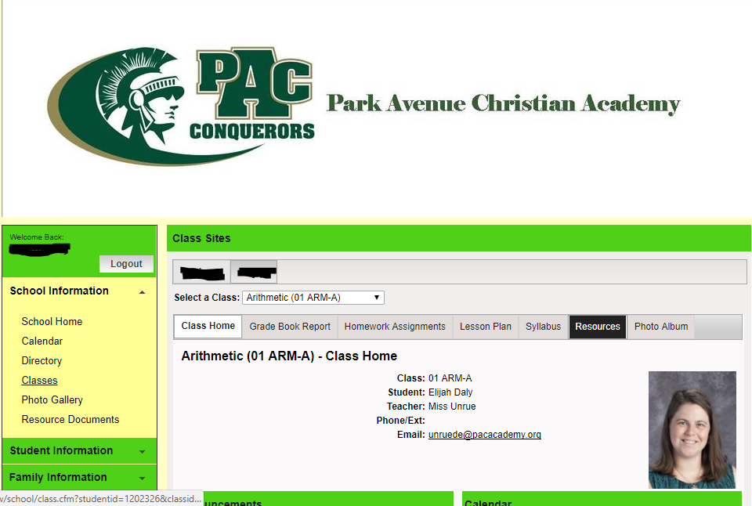
The Weekly Schedule for each week will be here.
